# LUA NINJA PLATFORM GAME - USER GUIDE

Hammada Ballali Ebbi – 20203543

CSCCORE1H001AZ2022/3 -- Coursework – IoT and Lua

## Description:

Ninja Lua Platform Game is a platform game written in Lua using the Love2D engine. The user controls Jack the Ninja. The goal is to reach the end of the level, dodge and knock down enemies in the path, and touch the flag to proceed to the next level. The game consists of three levels: Level 0, Level 1, Level 2.

## Tools:

To implement this program, several tools and libraries have been used:

* Love2D: A free open-source framework developed by Love developers.
* Anim8: Animation library for Love posted by Enrique Garcia Cota in GitHub.
* Hump: It implements a collection of tools for game programming.
* Tiled: A level editor.
* Simple-Tiled-Implementation: A library to implement Tiled maps.
* Windfield: A physics module for Love.

## 

## Implementation:

The code consists in:

* A main file.
* A file to implement the character controlled by the player.
* A file to handle the enemies.
* A file to implement the shots.
* Three scripts to implement the levels.

## Main:

It consists of seven functions:

* Function love.load: Allows you to set window size, import required libraries and load all the necessary elements before using them (Sounds, sprites, animations, world features, objects, etc)
* Function love.update(dt): It allows to update the frames at most 120 times by second. It is used to update the positions and sprites as well as to handle the level transitions.
* Function love.draw: It allows to show all the elements in the screen and to implement the camera.
* Function love.keypressed(key): It allows to set the jump, restart and shoot controls.
* Function destroyAll(): It is used to remove all items from one level before moving to the next.
* Function loadMap(Mapname): It allows to load a map after a level transition an to set the initial position of the elements within it.

## Player:

This file is used to set, update and draw the player character. It consists in:

* An initial script setting the initial values.
* Function playerUpdate(dt) to implement controls and animations.
* Function drawPlayer to show the character on the screen.

## Enemy:

It creates a table to store the enemies’ objects, then it adds three functions:

* Function spawnEnemy to create new objects and insert them in the table.
* Function updateEnemy(dt) to set the movements and collisions.
* Function drawEnemies to show the enemies on the screen.

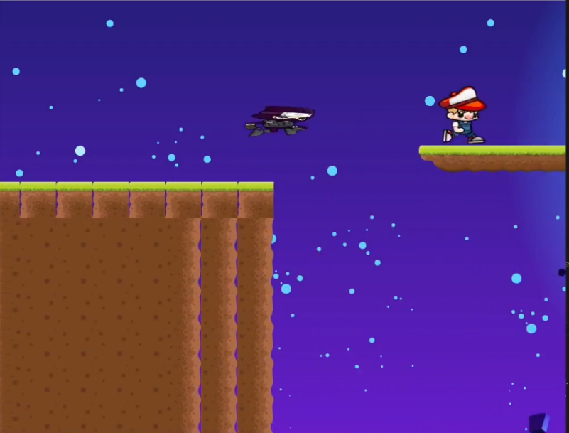

## Bullet:

It creates a table to store the bullets’ objects, then it adds three functions:

* Function spawnBullet to create new objects and insert them in the table.
* Function updateBullet(dt) to set the movements and collisions.
* Function drawBullets to show the bullets on the screen.

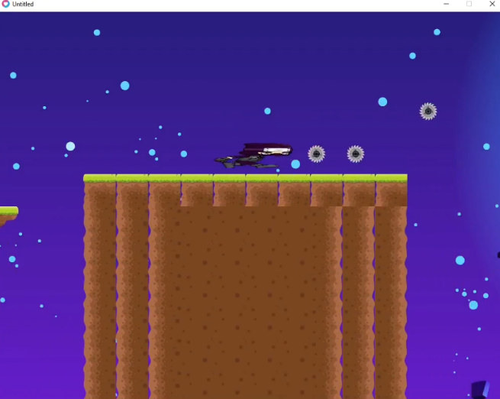

## Level files:

The levels are built using the Tiled software and then converted and exported to a lua file.

Three levels have been built for this game. An initial level 0 with a tutorial and 2 more levels.

